PRACTICAL FILE

OF

ARTIFICIAL INTELLIGENCE

CLASS XI

(SESSION:2023-2024)

SUBMITTED TO : NITIN GUPTA

SUBMITTED BY: NAMAN JAIN

CLASS:11-A

ROLL NO : 25

PROGRAMME-1

1 Write a python code to obtain basic salary from the employee and then calculate net salary where basic salary=home rent of 10.5% ,daily allowance of 3.8% and tax of 1.2%





PROGRAMME-2

2 Write a python code to obtain number of players for a particular game and then form number of teams and players left over (a team can have 9 players)





PROGRAMME-3

3 Write a python code to take 3 numbers from thwwe user and find the largest no among them

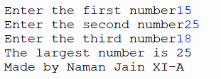

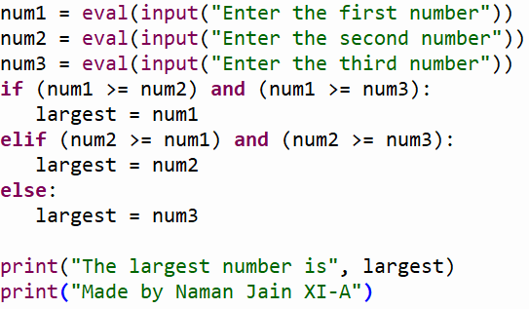

PROGRAMME-4

4 Write a python programme to obtain two numbers from the user and then interchange their values

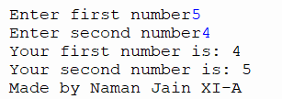

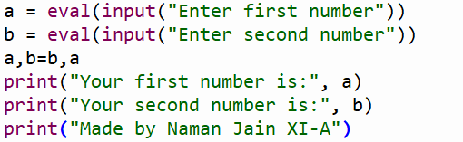

PROGRAMME-5

5 Write a python code to obtain three number from the user and display their average

